Curso Swift

Cleís Aurora – Digital HOuse

**Aula 0:**

Apresentação e pedido de foco e determinação

**Aula 1:**

Hello world e variáveis:

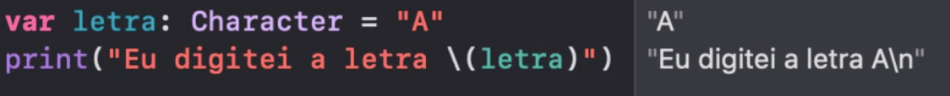





**Aula 2:**

Let, condicional, Laço de Repetição, array e dicionário

Fazer exercícios!!

**Aula 3:**